BULGARIAN INFORMATION SOCIETY
CENTER OF EXCELLENCE FOR
EDUCATION, SCIENCE, AND TECHNOLOGY
IN 21 CENTURY (BIS-21)

Professor Ivan Dimov, DSc; Institute for Parallel Processing, Bulgarian Academy of Sciences, Acad. G. Bonchev 25A, 1113 Sofia, E-mail: ivdimov@bas.bg
and
ACET, The University of Reading, Whiteknights, PO Box 217, Reading, RG6 6AH, UK, E-mail: I.T.Dimov@reading.ac.uk

Introduction
Information Technology (IT) is a broad subject concerned with the use of technology in managing and processing information. In particular, IT deals with the use of electronic computers and computer software to convert, store, protect, process, transmit, and retrieve information. For that reason, computer professionals are often called IT specialists, and the division of a company or university that deals with software technology is often called the IT department. Computer science, or computing science, is the study of the theoretical foundations of information and computation and their implementation and application in computer systems. Computer science has many sub-fields; some emphasize the computation of specific results (such as computer graphics), while others (such as computational complexity theory) relate to properties of computational problems.
The EU idea of establishing Centres of Excellence in the newly Associated States was very original and extremely fruitful for Bulgarian scientists. Thanks to our Centres of Excellence the position of Bulgarian science in EU has changed dramatically – it is now for more appreciated and its status is much higher. In a very hard competition with many leading institutions the Institute for Parallel Processing of the Bulgarian Academy of Sciences (IPP-BAS) succeeded to be granted as a Centre of Excellence. In the field of Mathematics, Informatics and Engineering there are six more institutions: one in Poland, one in Czech Republic, two in Hungary, one in Rumania, and one in Cyprus (see Figure 1).
Within the existing program for exchanging scientists among member countries, the Centre of Excellence at IPP-BAS has developed a real network of individual contracts among scientists, this promoting the training of young scientists and the exchange of doctoral students, which in turn activities the human research potential.

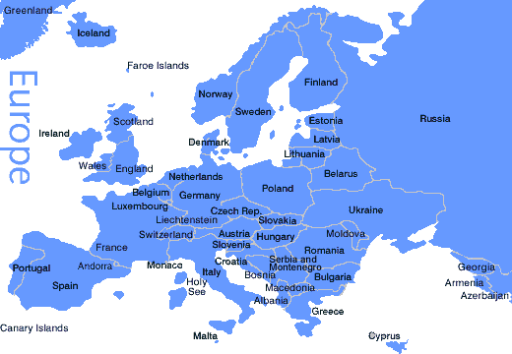

Fig. 1. CENTRES OF EXCELLENCE IN MATHEMATICS – INFORMATICS - ENGINEERING (MAIN-EN)

- Main Objectives of the Project BIS-21

One of the most important objectives of the project was further development of an excellent research and training institution (IPP-BAS), which kept leading expertise in information technologies.

Bulgarian Information Society Centre of Excellence for Education, Science and Technology BIS-21 prolonged the existing IPP’s tradition of fruitful collaboration as follows:

- In Information Technologies (IT) for large-scale computing and environment protection: co-operation and twinning with our partners: University of Reading (Reading, UK), National Environmental Research Institute (Roskilde, Denmark), Catholic University of Nijmegen (The Netherlands), Institute of Geonics CAS (Ostrava, Czech Republic and the University of Bristol (UK). The main objective is to exchange knowledge and expertise in the filed of development of large-scale computing systems for solving real-life problems in emergency forecast of damaging air pollution levels. BIS-21 allows for joint training of PhD students through exchange of visits and organisation of seminars and conferences on Large-Scale Computing Tools.
- In Human Language Technology (HLT): cooperation and twinning with 3 partners: University of Sheffield (UK), University of Hamburg (Germany), and University of Tubingen (Germany). The main objective is sharing knowledge in order to transfer technologies for processing of English/German to Slavonic languages, thus providing excellence in HLT for Slavonic languages as well as technologies for development of knowledge-based tools for natural language processing. BIS-21 supports joint training of Ph.D. students and qualification of post-docs through exchange of visits and sharing expertise.

- In Technologies for management of information processing, communications and networks: cooperation and twinning with

- 4 partners: NTUA, Greece, the University of Groningen, The Netherlands, and, CEO Mundial Avenue S.A., Brussels, Belgium, and the City University, London, UK with the main objective to exchange knowledge and expertise in the filed of high performance RISC processors based on VLSI PGA;
- 3 partners: Rheinish-Westfaelische Technische Hochschule (RWTH) Aachen, Germany, Helsinki University of Technology, Finland and the Academy of Economic Studies, Romania in order to exchange expertise in communication and network services as well as exchange of information about the activities in other IST Centres of Excellence.

The successful cooperation with partners from the University of Reading, Department of Computer Science, UK, the National Environmental Research Institute, Roskilde, Denmark, the University of Nijmegen, The Netherlands, The Institute of Geonics, SAC, Ostrava, Czech Republic, IRISA, Rennes, France and Hamburg University, Germany, has to be especially emphasized. The transfer of newest achievements in the field of error analysis, Monte Carlo methods and large-scale computing to real life applications in engineering and technology is one of the most important project’s features.

- BIS-21 Achievements

During the period of the project 53 long-stay visits and 30 short visit of EU scientists were realized.
For the period from 1 January 2001 we had:

- 83 ingoing visits;
- 90 outgoing visits.

During the period of the project we complete:
- 90 participations of Euro-conferences;
- 44 participations of workshops;
- 11 coordination travels.

The long-stay visits of EU scientists and students were distributed as follows:
- 6 visits of MS EU-students;
- 21 visits of PhD EU-students;
- 28 post-docs visits of EU-scientists;
- 3 visits of professors.

The distributions of different visits during the eight periods of the project are presented on pictures given below.

One can see that the distribution of our activities is more or less optimal and corresponds to the activities connected with the deliverables of the project.

During the period in a strong collaboration with our partners we obtained innovative results published in a number of journal papers and papers in proceedings of international conferences.

Running long-term experiments with real data takes a lot of time even on up-to-date parallel supercomputers. That is a rather challenging task for the powerful GRID infrastructure, which is already available in the framework of the ongoing projects EGEE and SEE-GRID. In connection with this goal it was very important to develop portable codes and test them on as much as possible supercomputers of various type and brand. For achieving best portability we were using only standard parallelization tools (MPI for distributed-memory parallelism and OpenMP for shared-memory parallelism). The results obtained in our Centre are published in Springer Lecture Notes in Computer Science, Vol. 3401.

One generic approach to improving the convergence of MCMs has been the use of highly uniform, quasirandom, numbers (QRNs) in place of the usual pseudo random numbers (PRNs). Quasi-Monte Carlo algorithms are based on the number theory and are carried out by deterministic low discrepancy point sets. Two quasi-Monte Carlo algorithms for boundary value problems, based on the use of good lattice points in the sense of Korobov, are proposed and analyzed. The study deals with finding optimal coefficients for good lattice points in weighted Sobolev and Korobov spaces. Two approaches are used to obtain such coefficients: “component-by-component” and obtaining the coefficients depending on single parameter by Korobov’s construction. Numerical tests are performed for a model, similar to some real-life problems in environmental mathematics. The results show that the convergence of the proposed algorithms is practically the same, but they have some advantage by comparison with Monte Carlo algorithm in high dimensions.

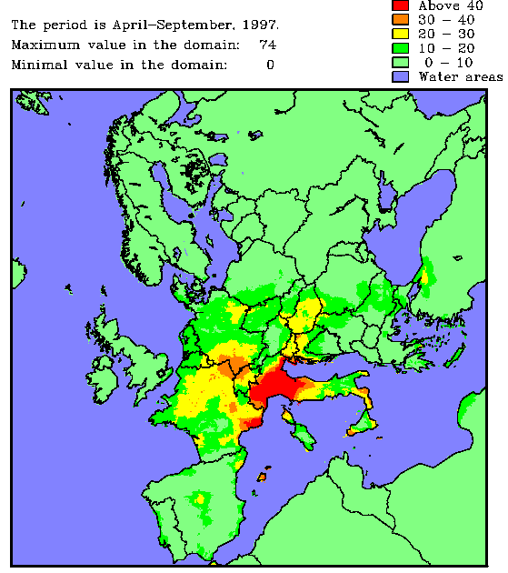

Fig. 2. BIS-21 provides Information Technologies for Emergency Situations Forecast.
The Flexible Modeling System developed at IPP-BAS is a basic tool for solving problems in the computer science, real-life problems of the modern society (ecological – an information for the decision makers about the ozone pollution obtained using our Macintosh G4 cluster, is presented).

Fig. 3. Ozone pollution in Bulgaria and the surrounding area

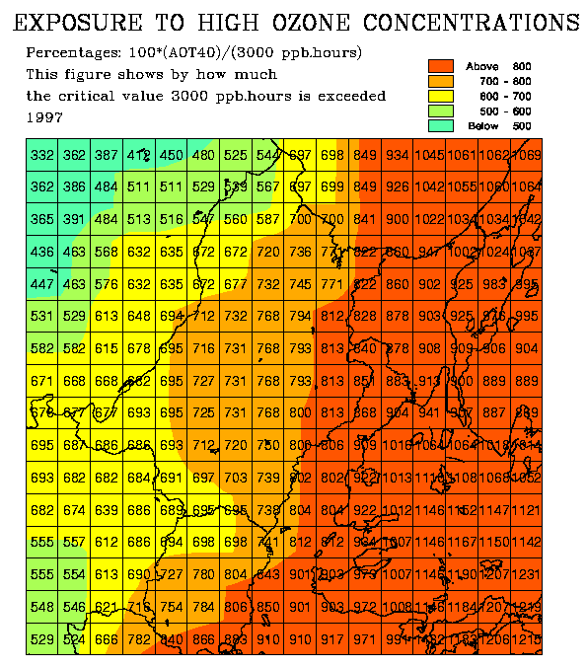

The following tasks in the field of scientific computing were under investigations during the reported period:

- Optimal Algebraic Multilevel Iteration (AMLI) methods for pure elasticity problems approximated by non-conforming FEM systems.
- Parallel solution methods for rotated bilinear FEM elliptic systems.
- Discussions of models, numerical discretization and solution approaches to be used for preparation of mutual collaborative research projects related to computer modeling and multi-scale phenomena and coupled problems.

The second major aspect of the planned work is related to the field of high level education.

BIS-21 project helped us to prepare several proposals (or parts of them) in the framework of the 6th FP. Two of them:

- EC Project # 002356 “South-Eastern European GRid-enabled eInfrastructure Development (SEE-GRID)” (Project Coordinator: J. A. Sanchez- Papaspiliu, GRNET, Greece, Contractor for IPP - BAS: I. Dimov), Call identifier: FP6-2002-Infrastructures-2, Contract type: Specific Support Action (VI Framework Programmee of EU), http://www.see-grid.org/

- EC Project # 508833 “Enabling Grids for E-science in Europe (EGEE)” (Project Coordinator: F. Gagliardi, CERN; Contractor for IPP - BAS: I. Dimov), (VI Framework Programmee of EU), http://public.eu-egee.org/
can be considered as a result of our active collaboration within BIS-21 project.

The further cooperation continue via the INCO project 016639 BIS-21++ (Bulgarian IST Centre of Competence in 21 Century), a Specific Support Action which is already running achieving significant results. BIS-21++ focuses on research training of young scientists (including PhD students) and further qualification of post-docs. The cooperation is based on the available BIS-21 results. The Bulgarian trainees will have joint supervision between one Bulgarian and one foreign senior researcher.

- Challenges for the Future
The networks and links created during the BIS-21 project have chance to continue in further development of our collaboration with most leading institutions in EU and USA. The BIS-21 project activities have a strong contribution to the international recognition of the RTD achievements of IPP BAS. This in particular results in the sustainable increase of the scientific publications in some of the best international journals and series. Building up of networking and twinning activities is an inherently integrated part of BIS-21. The obtained results motivated by the realized long stay visits to IPP BAS are one of the best contributions to the real strengthening of the European Research Area in such fields as information technologies for environmental protection, human language technologies, and technologies for management of information processing, communications and networking. The BIS-21 workshops, and a number of traditional scientific conferences organized by IPP BAS, became forums for promotion of new ideas and active exchange of research and technological results. The increased capacity of the research groups of IPP BAS results in their active and successive involvement in FP5 and FP6 proposals. As an example, IPP BAS is one of the initiators and a co-founder of the recently established Bulgarian GRID Consortium, facing the new priorities of FP6. One important accent in our current activities as a research partner of Bulgarian industry and SMEs is substantially to shorten the innovation cycle.
Nevertheless, we trust that the European joint research should be organized by more systematic way, if we want to compete with US scientific and technological programmes where large budgets are available without annoying administrative obstacles. That is why we support the idea which appeared during the Yearly meeting of Centres of Excellence in Cyprus to support few virtual excellent Joint Research Centres– in fact networks of closely collaborated excellent research units – in themes which are for Europe vital and are not covered by existing research priorities. Our strong point is that the European Centre of Excellence should play an important role in further development of successful academic scientific collaboration in Europe.
As a very successful Centre of Excellence IPP-BAS was granted by BIS-21++ Project “Bulgarian IST Centre of Competence in 21 Century”. The project started in 2005 and is still running. The general objective of BIS-21++ is to further strengthen the human potential and to reinforce the excellence in education, science, and technology of the currently most established Bulgarian IST Centre. BIS-21++ is relevant to the objectives of the Call to “improve the research capacities of highest quality and promising centres”. To meet the Call objective for “reinforcing the scientific potential”, BIS-21++ emphasizes on training of young scientists.

Strengthening the scientific potential of IPP-BAS. A number of new young scientists will be supported by IPP-BAS using the EC support from BIS-21++. In order to ensure the context for the high-quality training of the scientists and provide the framework of their professional growth, IPP-BAS senior staff members will organise and supervise 8 RTD tasks in key IST areas:
- New Computational Grid Technologies for Emergency Forecast,
- Computationally Intensive Problems: Monte Carlo Simulations with Grid Applications,
- Robust Scientific Computing Algorithms and Software Tools,
- Improved Computer Systems Recovery and Intelligent Stores,
- Plausible and Paradoxical Reasoning in Sensor Data Processing,
- Multilinguality in Advanced Information Search,
- Formal Structures in Large-Scale Search and Semantic-Based Applications,
- Computer Networks and Grid Infrastructures.

Acknowledgements

This work was supported by BIS-21 project (ICA1-CT-2000-70016) as well as by BIS-21++ project (FP6-2004-ACC-SSA-2).

